2017 was a banner year for point guards. The media selected five of them for All-NBA teams at the end of the year (1st: Russell Westbrook, James Harden; 2nd: Steph Curry, Isaiah Thomas; 3rd: John Wall) and eight of them were voted into the All-Star Game at midseason (those five, plus Kemba Walker, Kyle Lowry, and Kyrie Irving). And we haven’t even mentioned Chris Paul yet, who many still worship as the Point God (and correctly so).

Given how efficiently modern basketball is played, it’s sometimes hard to imagine the game being played any other way. It makes sense that point guards should be dominating in a game centered on pick-and-roll, floor spacing, and drive-and-kick.

However, this current “golden age” of point guards hasn’t been around for all that long, actually. You don’t need to go back many years to find a time when bigs still ruled the court. The rise of the point guard has been fast and furious, upending the traditional hierarchies of the sport (although as we’ll see in the data, bigs are still doing fine).

But instead of relying on our intuition, let’s see if there’s some statistical backing to the intuition that point guards are dominating basketball to a greater degree than they used to.

Exhibit A: Rising share of NBA’s best individual seasons

One potential measure of a “golden age” could be the extent to which point guards produce a disproportionately large share of the league’s top individual seasons. Using win shares per 48 minutes (WS/48) from Basketball Reference as the overall performance metric and defining “top individual seasons” as those in which a player ranks in the top 10 of WS/48 for that year, we can find out for any given year how many of the top individual seasons were produced by point guards, wings, and bigs.

Let’s graph each of these three positional categories against each other starting from 1985 (and using a rolling 3-year average so that random blips smooth out and don’t throw off the numbers too much):

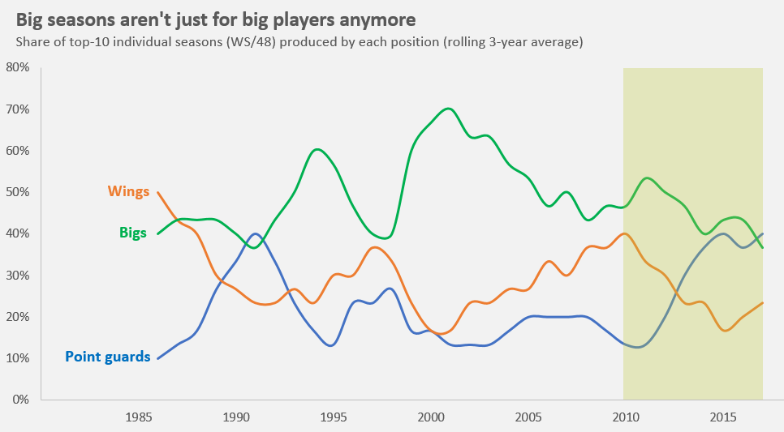

Note: Nominally, “wings” and “bigs” comprise two positions each while point guard is just one position, so it makes sense that point guards would generally produce a lower share of top individual seasons (which makes the recent rise even more remarkable).

Some observations:
- Wings: Elite individual production from wing players has generally been steady but unspectacular, and in recent years, it has been diminishing
- Bigs: For a long time, basketball has been a game where size matters, and while it still matters some, bigs’ share of top individual seasons has steadily declined since the turn of the millennium (but holy sh*t, in 1999, bigs produced nine of the top ten individual seasons: David Robinson, Shaquille O’Neal, Karl Malone, Alonzo Mourning, Charles Barkley, Tim Duncan, Arvydas Sabonis, Dikembe Mutombo, Shawn Kemp; only John Stockton saved the league from a sweep)
- Point guards: Point guards right now are enjoying their best elite individual production since the turn of the 90s when it was Magic Johnson, John Stockton, and Kevin Johnson holding it down (and Terry Porter tho?!). They’ve also made up ground in a hurry since the start of this decade, and in 2017, five of the league’s top ten individual seasons were accomplished by point guards (Paul, Harden, Thomas, Curry, Westbrook).

Exhibit B: The ten best at each position

The NBA has apparently changed a lot since just 2010, so let’s take a closer look at those years and try to ask our question another way: Have the elite (say, top 10) point guards, as a whole, caught up to the elite players at other positions?

Depicted below is the average Player Efficiency Rating (PER) of the elite players at each of the five traditional positions:

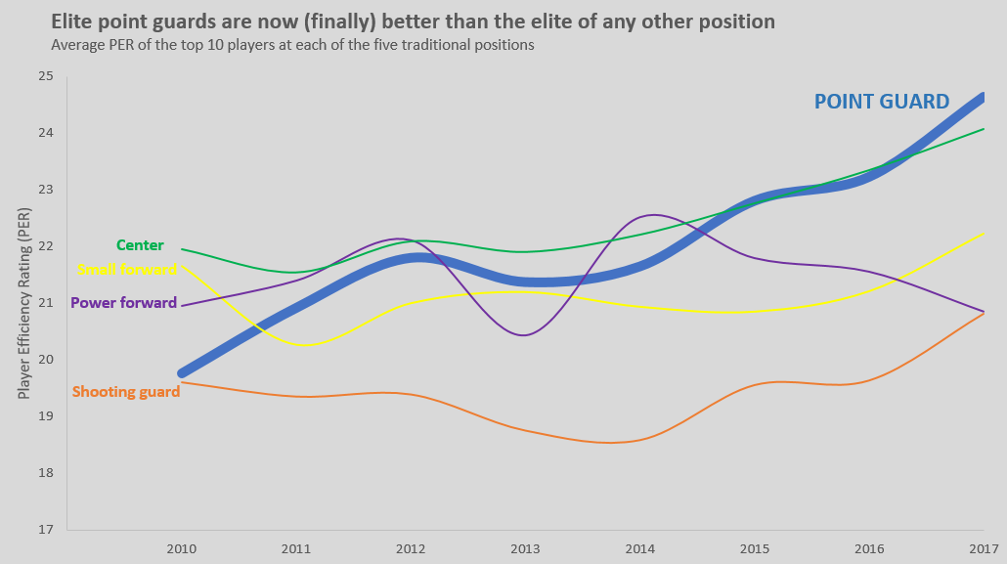

With Russell Westbrook leading the charge (30.7 in his 2016-2017 MVP campaign), point guards have now not only caught up, but distanced themselves from the nearest challengers (centers) by more than half a PER point. The phenomenon we observed in Exhibit A, the rapid ascent of point guards since 2010, appears to be corroborated here. It’s a stacked position now, but in 2010, Andre Miller (who I swore was washed up by then, but apparently not, but definitely at least kinda) snuck into the top 10 of PER among point guards, which lets you know how not-stacked it was just seven years ago.

Exhibit C: Usage rate

If point guards were leading the game nowadays, you might expect to see the best point guards increasingly entrusted with the ball in the modern game. Usage rate stats starting in 2010 show that PER top-10 point guards indeed are dominating the ball more and more, cracking 30%+ this past season:

The best point guards are
getting the ball more
Average usage rate of the top 10 point
guards (by PER) in each season

SEASON | USAGE RATE
2017 | 30.32
2016 | 29.03
2015 | 27.73
2014 | 26.49
2013 | 25.24
2012 | 26.35
2011 | 25.04
2010 | 24.73

Some caveats: These stats don’t prove that we’re in the golden age of point guards per se, although they do support that hypothesis to some extent. Basketball is also a game that is constantly evolving, so you can be sure that this wave of point guard dominance will eventually crest at some point as teams gradually figure out other inefficiencies to exploit.

However, this current wave doesn’t show signs of stopping just yet. Analytics have ushered in the “pace and space” era of basketball, in which a playmaker to push, score, and distribute the ball is arguably the most valuable asset a team can have. That player doesn’t always have to be a point guard, of course, but the job description does fit nicely. We also just witnessed a draft in which the top two selections (Markelle Fultz and Lonzo Ball) were point guards, as well as three others within the top nine picks (De’Aaron Fox, Frank Ntilikina, and Dennis Smith Jr.).

It’s been a while, but point guards are finally having their moment.

