The NBA hasn’t crowned a defense-oriented MVP since 1994 Olajuwon

Uncle Drew once lamented in a Pepsi commercial that today’s players didn’t really know basketball, saying “what these young bloods have to understand … this game has always been, and always will be, about buckets.”

Well, if our history of NBA MVP voting is any indication, Uncle Drew has nothing to worry about. We’ve always focused on buckets.

According to win shares (WS, per Basketball Reference), 79% of MVPs in the last 60 years have been players who contributed more than half of their win-share value through offense. This trend is even more pronounced in recent years: The last 22 MVPs have been offense-oriented players, with Hakeem Olajuwon in 1994 being the last player to win MVP primarily through defensive contributions. Given that defense is (ahem) half of the game and the half that we so often preach as being more crucial to winning championships, this trend is very <thinking face emoji>.

It hasn’t always been this way. During the first decade for which Basketball Reference has data (1956-1965), MVPs contributed just 41.1% of their value through offense, on average. The most extreme example from this era is Bill Russell’s 1963 season, in which he contributed only 7.4% of his value through offense (1 win share on offense, 12.6 win shares on defense)!

However, if you divide the Basketball Reference data into six decade bins, you’ll see that the share of MVPs’ value that comes from offense has increased almost every decade (see table below), with MVPs from the most recent decade contributing 72.7% of their value through offense. The player most analogous to 1963 Bill Russell in recent history is 2004 Ben Wallace (1.1 WS offense, 9.1 WS defense), and he finished a distant seventh in MVP voting.

Decade | Share of MVPs’ value  derived from offense
1956-1965 | 41.1%
1966-1975 | 55.4%
1976-1985 | 62.5%
1986-1995 | 67.5%
1996-2005 | 65.8%
2006-2016 | 72.7%

Check out two more graphs about the statistical profiles of MVPs throughout the years:

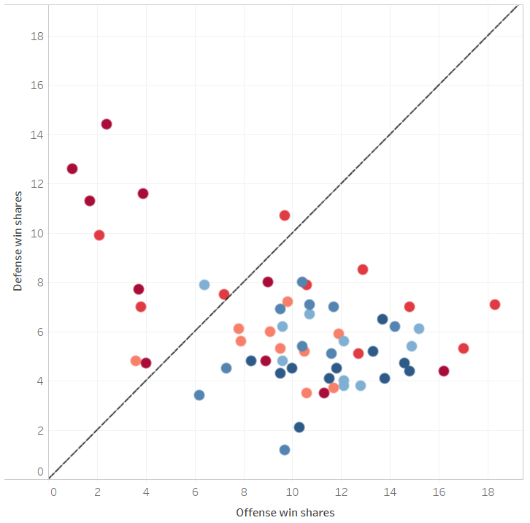
The diagonal indicates a balanced offense-defense profile. Notice how many of the early MVPs (red-ish dots, darker indicating earlier seasons) are above the diagonal (defense-oriented) and how many of the recent MVPs (blue-ish dots, darker indicating more recent seasons) are below it (offense-oriented). Also, notice how most MVPs are offense-oriented in general.

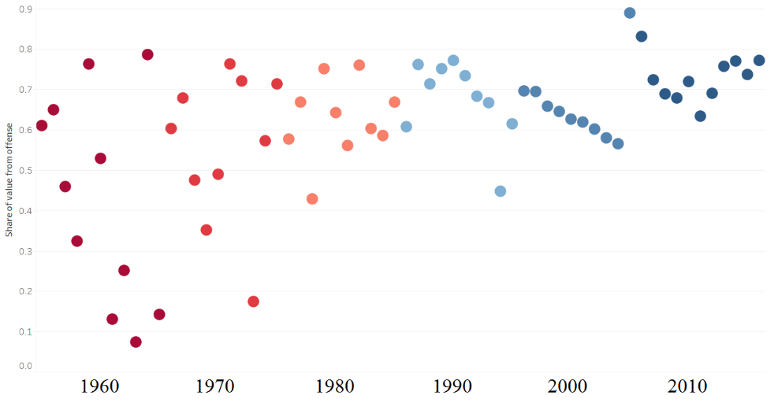

And here, we see that the profiles of MVPs varied much more widely in the early days, while nowadays only offense-oriented players win the award.

Our understanding of basketball is much more nuanced now than it has been ever before, so why is it still “glitzy” offense that catches our eye perhaps more than it should?

Well, for one, defense prowess has always been much more difficult to judge because a lot of the value comes in things that *don’t* happen. Quantifying the value of late-2000s Dwight Howard deterring players from even attempting to drive, for example, is relatively tough.

However, it might also be true that the ceiling for offensive impact is higher than for defense, so players who are great on offense indeed actually exert more influence than great defensive players. A look at more win-share statistics supports this notion (single-season records for win shares: offense, defense):
- The top seven seasons on one side of the ball are from offense
- There have been 169 seasons in which a player has produced double-digit offensive win shares, but only 8 seasons in which a player has done the same on defense

So it might not be that voters just look toward shiny things on offense – basketball, as it’s played in the NBA, is likely a sport in which individual brilliance on offense is more impactful than individual brilliance on defense, so it tends to be great offensive players that put up more of the historic win-share totals. MVPs aren’t selected by win shares, of course, but win shares are a decent indication of the overall impact that MVP voters presumably look for.

How does this year’s MVP race stack up to past races? Let’s take a look at the top ten candidates according to Basketball Reference’s predictive model (as of Saturday):

Player | MVP probability | Offense win shares | Defense win shares | Total  win shares | WS% derived from offense
James Harden | 40.1% | 8.6 | 2.8 | 11.4 | 75.4%
Kevin Durant | 24.9% | 7.7 | 3.7 | 11.4 | 67.5%
LeBron James | 10.9% | 6.7 | 2.4 | 9.1 | 73.6%
Russell Westbrook | 6.2% | 5.0 | 3.3 | 8.3 | 60.2%
Stephen Curry | 6.2% | 6.3 | 2.6 | 8.9 | 70.8%
Kawhi Leonard | 5.8% | 6.6 | 3.2 | 9.8 | 67.3%
Isaiah Thomas | 2.6% | 8.7 | 0.8 | 9.5 | 91.6%
Kyle Lowry | 1.2% | 7.7 | 1.7 | 9.4 | 81.9%
John Wall | 0.8% | 3.8 | 2.5 | 6.3 | 60.3%
Jimmy Butler | 0.8% | 7.0 | 2.2 | 9.2 | 76.1%

Offense accounts for 72.5%, on average, of the win-share value provided by this year’s MVP contenders, which is on par with the historical trends that we saw previously. Even players that we usually associate with defensive focus (Kawhi Leonard, Jimmy Butler) contribute two-thirds and three-quarters of their value on offense, respectively. It’s safe to say that we probably won’t be seeing a MVP season like 1963 Bill Russell again any time soon.

The saying is that defense wins championships (debatable), but more often than not it’s offense that wins MVPs. The young bloods of today’s NBA know that more than anyone.

